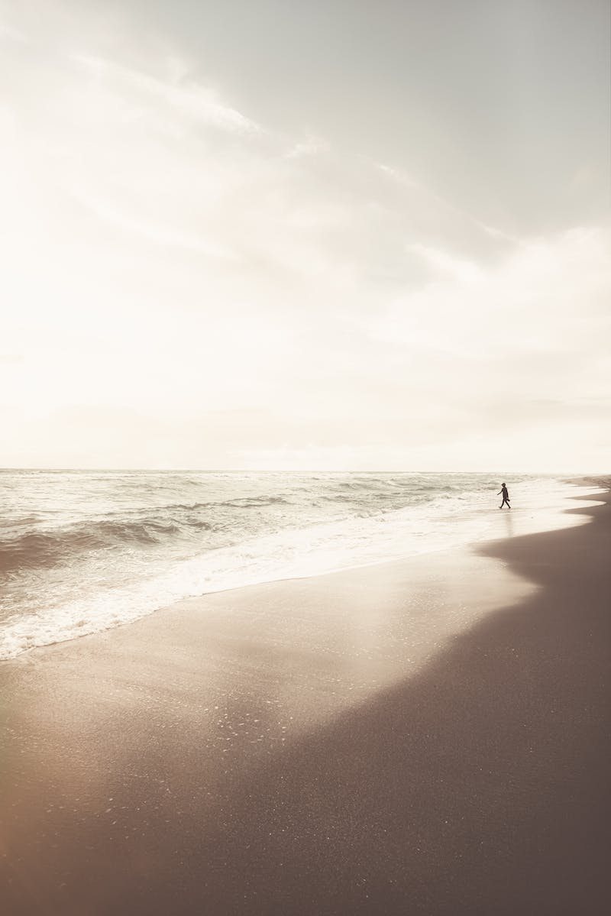

Task 1 (Trapani, n.d.)

Cover Page

Nicholas Walters 001013686 | WGU C856 | 07/30/2023

# Timeline

# Persona

# Flow Diagram

# C.Wireframe Mobile Homepage Flow (figma/icons, n.d.)

# C.1-Wireframe Mobile FAQS (figma/icons, n.d.)

# C.2-Wireframe Mobile Contact Us (figma/icons, n.d.)

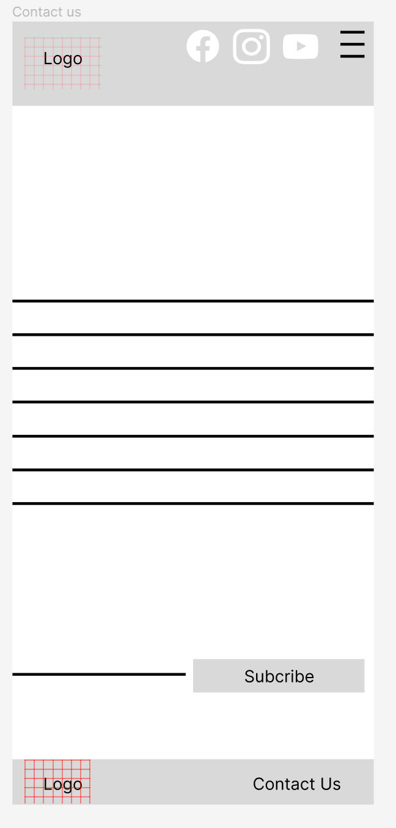

# C.3-Wireframe Mobile Things To Do (figma/icons, n.d.)

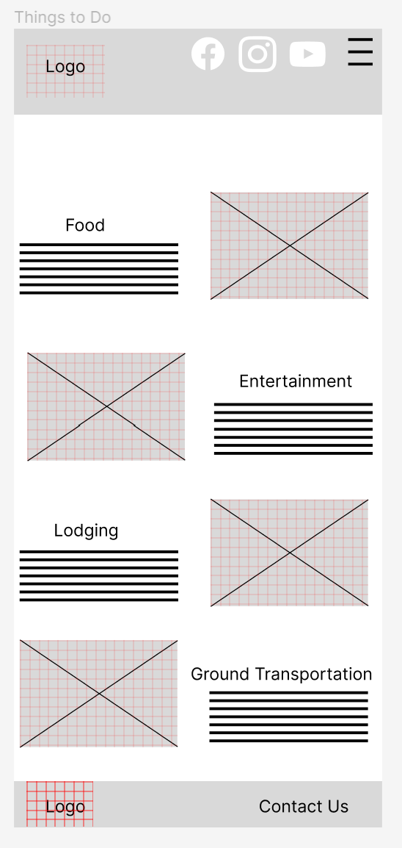

# C.4-Wireframe Mobile Book Today (figma/icons, n.d.)

# C.5-Wireframe Mobile Testimonials (figma/icons, n.d.)

# C.5-How to Get Here (figma/icons, n.d.)

# D.1 Guerilla Testing (Prototype Prior To Feedback Link= <https://www.figma.com/proto/IuPCxpBxeZIJYh2fWE0WPi/Taniti-Website-Project?page-id=153%3A244&type=design&node-id=153-292&viewport=2597%2C2227%2C0.71&t=kb4b4M9GTe4MLVJm-1&scaling=min-zoom&starting-point-node-id=153%3A292&mode=design>) Users

User 1

(Hladynets, n.d.; Hladynets, n.d.)

User 2

(Hladynets, n.d.)

User 3

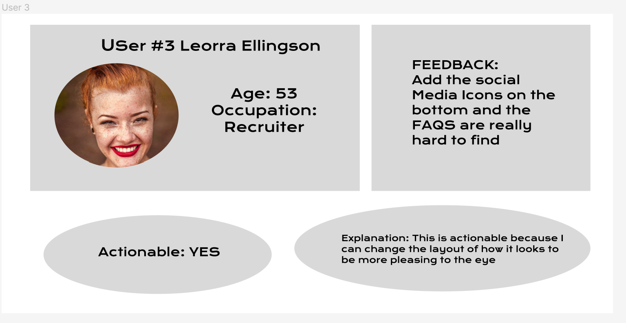

(Silverio, 2017)

# D.2 Guerilla Testing Summary

The feedback I received was all positive. They really liked the idea of having a working mobile website. They all really liked how it flowed.

Xavier wanted the site’s hamburger menu to work or to have a function. This will be actionable because I can make it happen. I will be able to add functionality to the hamburger menu and have it have some useful links. I will incorporate this into my design by adding links to the menu page. This way people on a phone will be able get the answers they need.

Justin “Leo” wanted the site to have a promotion or coupon to keep the customers coming. This is actionable because I want the customer to continue visiting the site. This will enable the tourists to find the daily deal or promotion. This information will also be useful for us so that we will know if there are any activities that the customer isn’t in to and we can plan accordingly. I will incorporate this onto the homepage right when they visit the home page as a pop up.

Leora wanted the site’s social media icons on the bottom and thought the FAQS were hard to find. The FAQS were only on the main page. Both the social media icons and the FAQS are actionable. I will be able to place the social media icons towards the bottom of the page. This will make it more pleasing to the eye. I will also incorporate the FAQS as a link from the hamburger menu, that way they are visible on more than one page. After the site gets launched, we will be able to add functionality to the social media icons and have them go to our pages on those platforms.

# E. Interactive Prototype Link

<https://www.figma.com/proto/IuPCxpBxeZIJYh2fWE0WPi/Taniti-Website-Project?page-id=235%3A374&type=design&node-id=235-375&viewport=557%2C1088%2C0.9&t=Wpg7mX4KnldpnMRD-1&scaling=min-zoom&starting-point-node-id=235%3A375&mode=design>

# F. 5 Usability Tasks

1. Find information about food.

2. Go to the FAQS page.

3. Hit the “Send Email” button in the Contact Us section

4. Check the functionality of the hamburger menu.

5. Go to the testimonials page.

# G Sources Cited

(n.d.). Retrieved from unsplash.com

(n.d.). Retrieved from https://unsplash.com/

*figma/icons*. (n.d.). Retrieved from www.figma.com

Gonzales, J. (2017, October 2). Retrieved from unsplash : https://unsplash.com/photos/iFgRcqHznqg

Hladynets, V. (n.d.). *https://unsplash.com/@vhladynets*. Retrieved from unsplash.com: https://unsplash.com/photos/C8Ta0gwPbQg

Silverio, G. (2017, March 13). Retrieved from unspash: https://unsplash.com/photos/u3WmDyKGsrY

Trapani, T. (n.d.). Retrieved from www.pexels.com: https://www.pexels.com/search/peaceful/